STATIONARY TIME SERIES MODELS

**INTRODUCTION**

***Problem Description:*** Here in this problem we are interested in

1. Generating a AR(2) process of size 1000. Choosing the parameters from the stationarity region. Comment about the behaviour of acf and pacf
2. Generating an MA(3) process of size 500.Check if the process stationary? Comment on its acf and pacf plots.
3. Generating an ARMA(1,2) process of size 1000.Check if the process stationary? Comment on its acf and pacf plots.
4. Generating an ARMA(3,2) process of size 1000. Examine its charactersitics polynomial and obtain its characterstics roots.

***Objective:*** The main objective of this assignment is to geth the basic understanding of various basic stationary time series model by generating these process using simulation and understand their behaviour using acf and pacf plot.

The three stationary time series model that we want to study are:

1. Auto regressive process
2. Moving average process
3. Auto regressive moving average process

***Auto regressive process:*** An autoregressive (AR) model predicts future behavior based on past behavior. It’s used for forecasting when there is some correlation between values in a time series and the values that precede and succeed them. You only use past data to model the behavior, hence the name autoregressive (the Greek prefix auto– means “self.” ). The process is basically a linear regression of the data in the current series against one or more past values in the same series.

AR models are also called conditional models, Markov models, or transition models.

An AR(p) model is an autoregressive model where specific lagged values of yt are used as predictor variables. Lags are where results from one time period affect following periods.

The value for “p” is called the order. For example, an AR(1) would be a “first order autoregressive process.” The outcome variable in a first order AR process at some point in time t is related only to time periods that are one period apart (i.e. the value of the variable at t – 1). A second or third order AR process would be related to data two or three periods apart.

***Moving average process:*** In time series analysis, the moving-average model, also known as moving-average process, is a common approach for modeling univariate time series. The moving-average model specifies that the output variable depends linearly on the current and various past values of a stochastic term.

***Auto regressive moving average process:*** Moving average models capture the fact that returns depend not only on current information, but also on signals that have arrived over a previous stretch of time. This could happen if new information is only gradually absorbed or reaches market participants at different points in time. As a consequence, any new signal has not only an immediate, but also a delayed, effect.

Autoregressive models assume that there is a linear relationship between current returns and their own history. This type of model can be used when (some) investors base their decisions on recent price movements: in a bull market, profits attract more buyers who will drive up the price even further; and falling prices are seen as a sell signal that will prolong the downward movement.

These two concepts can be combined; not surprisingly, the resulting model is then called autoregressive moving average model, ARMA(p,q)

**ANALYSIS**

*#Setting and getting the current working directory.*  
**setwd**("E:/M.Sc/SEM III/TIME_SERIES_ANALYSIS(MST371)/Practical Labs")  
**getwd**()

## [1] "E:/M.Sc/SEM III/TIME_SERIES_ANALYSIS(MST371)/Practical Labs"

* 1. **Generate an AR(2) process of size 1000. Choose the parameters from the stationarity region . Comment about the behaviour of acf and pacf.**

*#Generating a auto regressive process of order 2 of size 1000 with parameter 0.3 and 0.1.*  
AR2=**arima.sim**(model=**list**(ar=**c**(0.3,0.1)),n=1000)  
  
*#Obtaining the acf plot for auto regressive process of order 2.*   
**acf**(AR2)

**ACF PLOT OF AR (2) PROCESS: FIGURE 1**

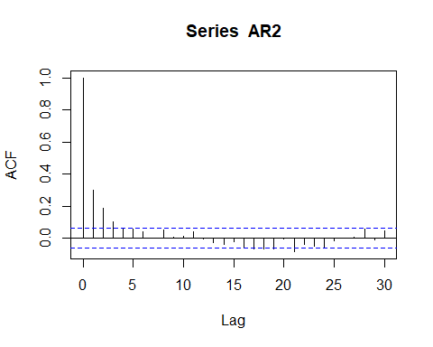

*#Obtaining the pacf plot for auto regressive process of order 2.*   
**pacf**(AR2)

**PACF PLOT OF AR (2) PROCESS: FIGURE 2**

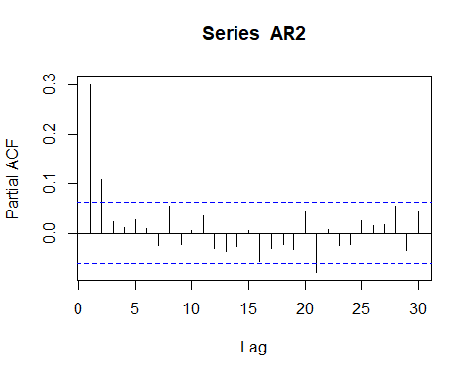

***Interpretation:*** From the acf plot we see that the acf plot is oscilatory in nature which proves the fact that the generated process is autoregressive process.

Also from the pacf plot we observe that there are consecutive significant lag values till lag 2 thus it is evident that the autoregressive process is of order 2.

1. **Generate an MA(3) process of size 500. Is the process stationary? Comment on its acf and pacf plots.**

*#Generating a moving average process of order 3 of size 500 with parameter 0.3, 0.1, and 0.4.*  
MA3=**arima.sim**(model=**list**(ma=**c**(0.3,0.1,0.4)),n=500)

*#loading the package 'tseries'*  
**library**(tseries)

## Warning: package 'tseries' was built under R version 4.0.5

## Registered S3 method overwritten by 'quantmod':  
## method from  
## as.zoo.data.frame zoo

*#Now we want to validate for the stationarity of the process using Augmented Fuller(ADF test) test. Dickey*  
**adf.test**(MA3)

## Warning in adf.test(MA3): p-value smaller than printed p-value

##   
## Augmented Dickey-Fuller Test  
##   
## data: MA3  
## Dickey-Fuller = -6.9542, Lag order = 7, p-value = 0.01  
## alternative hypothesis: stationary

***Interpretation:*** From the adf test we observe that p value is less than 0.05 which means that we reject the null hypothesis and conclude that the process is stationary process.

*#Obtaining the acf plot for moving average process of order 3.*  
**acf**(MA3)

**ACF PLOT OF MA (3) PROCESS: FIGURE 3**

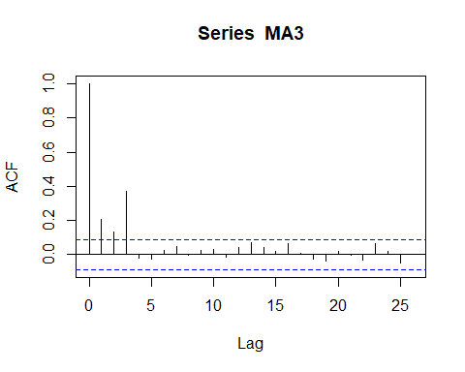

*#Obtaining the pacf plot for moving average process of order 3.*  
**pacf**(MA3)

**PACF PLOT OF MA (3) PROCESS: FIGURE 4**

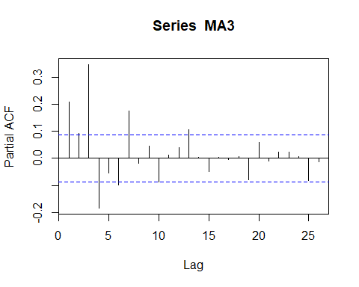

***Interpretation:*** From the acf plot it observed that the plot is oscilatory in nature and there are consecutive significant values till lag 3 thus it is a MA model of order 3.

1. **Generate an ARMA(1,2) process of size 1000. Is the process stationary? Comment on its acf and pacf plots.**

*#Generating a auto regressive moving average process of order 1,2 of size 1000 with parameter 0.4 and 0.7,0.2.*  
arma12=**arima.sim**(model=**list**(ar=0.4,ma=**c**(0.7,0.2)), n=1000)  
  
*#Obtaining the acf plot for auto regressive moving average process of order 1,2.*  
**acf**(arma12)

**ACF PLOT OF ARMA (1,2) PROCESS: FIGURE 5**

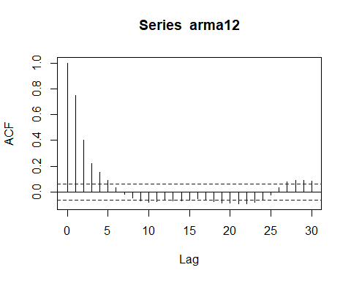

*#Obtaining the pacf plot for auto regressive moving average process of order 1,2.*  
**pacf**(arma12)

**PACF PLOT OFARMA (1,2) PROCESS: FIGURE 6**

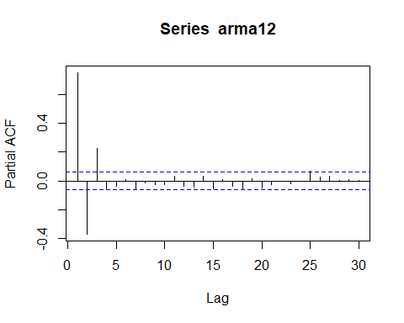

***Interpretation:*** The acf of the autoregressive moving average process has the acf plot which is oscillatory in nature.

From the pacf plot we can observe that there consecutive significant values of lag till lag 3 thus it is a ARMA model of order 1,2

*#loading the package 'tseries'*  
**library**(tseries)  
  
*#Now we want to validate for the stationarity of the process using Augmented Fuller(ADF test) test. Dickey*  
**adf.test**(arma12)

## Warning in adf.test(arma12): p-value smaller than printed p-value

##   
## Augmented Dickey-Fuller Test  
##   
## data: arma12  
## Dickey-Fuller = -9.5998, Lag order = 9, p-value = 0.01  
## alternative hypothesis: stationary

***Interpretation:*** From augmented dickey feller test we observe that the p value is less than 0.05 thus it is a stationary process.

1. **Generate an ARMA(3,2) process of size 1000. Examine its charactersitics polynomial and obtain its characterstics roots.**

*#Generating a auto regressive moving average process of order 3,2 of size 1000 with parameter (0.4,0.1,0.2) and (0.7,0.2).*  
arma32=**arima.sim**(model=**list**(ar=**c**(0.4,0.1,0.2),ma=**c**(0.7,0.2)), n=1000)  
  
*#Obtaining the acf plot for auto regressive moving average process of order 3,2.*  
**acf**(arma32)

**ACF PLOT OF ARMA (3,2) PROCESS: FIGURE 7**

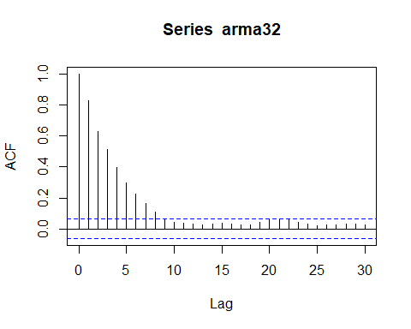

*#Obtaining the acf plot for auto regressive moving average process of order 3,2.*  
**pacf**(arma32)

**PACF PLOT OF ARMA (3,2) PROCESS: FIGURE 8**

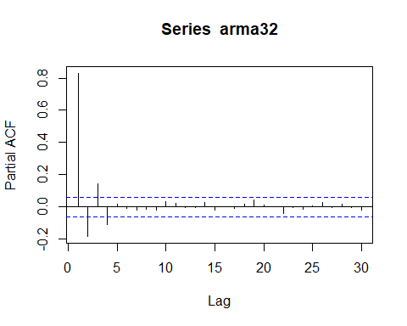

***Interpretation:*** From the acf plot it is observed that the graph is exponentially decreasing in nature thus we can say the ARMA process of order 3,2 is exponentially decreasing in nature.

*#Examining the characterstic polynomial of order 3,2 and obtaining the characterstic root.*  
  
*#The characterstic polynomial for ARMA(3,2) process is 1-phi1*B-phi2*B^2 - phi3*B^3 i.e. 1-0.4B -0.1B^2-0.2B^3 => 0.2B^3 + 0.1B^2 + 0.4B - 1 =0*  
  
*#Loading the package 'Rconics' to obtain the roots.*  
**library**(RConics)

## Warning: package 'RConics' was built under R version 4.0.3

*#Obtaining the root of the characterstic polynomial.*  
b<-**c**(0.2,0.1,0.4,**-**1)  
**cubic**(b)

## [1] 1.219994+0.000000i -0.859997+1.832699i -0.859997-1.832699i

Thus the roots for that characterstic polynomial of ARMA process of order 3,2 are obtained.

**CONCLUSION:**

Thus, in the above analysis we have simulated all the stationary time series model, checked if they are stationary usinf adf test, and commented on their acf and pacf behavior.